Mobile Project

User Interface Design

Version 1.0

07/25/23

Benny Iko

**1. Introduction 3**

1.1. Purpose 3

1.2. Scope 3

1.3. Reference Documents 4

1.4. Terms, Abbreviations and Acronyms 4

1.5. Assumptions and Constraints 4

**2. Graphical Interface Design 5**

2.1. VOI Mobile Application Landing Page 5

2.1.1. VOI Button Hover 5

2.1.2. VOI Button Selected 7

2.1.3. VOI Button Normal 9

2.1.4. VOI Table 11

2.2.1. VOI Error Reporting 13

## 

# Introduction

## Purpose

*This section gives a brief description of the purpose of this document.*

The purpose of this document is to showcase the proposed design, and to briefly explain how the UI empowers the user with ability to complete use cases, without going into extraneous details.

## Scope

*This section defines the scope of the interface design. This could include the application or modules within the application.*

The scope of the interface design includes the implied contract between the high-level requirements and their representative visual components, to be specified within. This document will **NOT** include the design of the login screen(s). The Vehicles of Interest (VOI) project will require separate designs for the desktop, mobile and web interfaces. However, this document is scoped to only provide the design for the mobile application portion of the VOI project. Stated differently, this document specifies how the core functionality, as mentioned below, will be presented to the user via mobile application implemented using HTML5, CSS, and JavaScript. This document will cover the design of the interface for the following business use cases. By requirement, the design shall be implemented using HTML5, CSS, and JavaScript.

* The system gives officers located at Headquarters the ability to perform CRUD operations (Create, Read, Update, and Delete) through the Web application.
* The system shall track the reasons for interest in a particular vehicle.
* This tracking information will initially include some values and descriptions (Silver Alert, Amber Alert, etc.).
* For reasons for interest, data for the reason and a description of the reason will be included.
* For vehicles of interest, the data stored and displayed must include license plate number, make, model, color, year manufactured, owner’s name and owner’s phone.
* For vehicles of interest, the data stored and displayed will sometimes include the year, color and owner’s information are unknown; so, they should appear as optional fields.
* The Headquarters must keep an up to date list of vehicle makes and models.

## Reference Documents

*If there are any document references, including requirement documents, reference them there.*

JavaServer Faces Component Presentation Instructions

<https://learn.umgc.edu/d2l/le/content/769946/viewContent/30624692/View>

MoreVOISQL

<https://learn.umgc.edu/d2l/le/content/769946/viewContent/31066428/View>

User Interface Design Template

[*User Interface Design Template - SWEN 661 9040 User Interface Implementation (2235) (umgc.edu)*](https://learn.umgc.edu/d2l/le/content/769946/viewContent/30624674/View)[*User Interface Design Template - SWEN 661 9040 User Interface Implementation (2235) (umgc.edu)*](https://learn.umgc.edu/d2l/le/content/769946/viewContent/30624674/View)

Vehicles of InteresttDB.sql

[*VehiclesOfInteresttDB.sql - SWEN 661 9040 User Interface Implementation (2235) (umgc.edu)*](https://learn.umgc.edu/d2l/le/content/769946/viewContent/30624685/View)

Vehicles of Interest Introduction (Overview)

[*Vehicles of Interest Introduction (Overview) - SWEN 661 9040 User Interface Implementation (2235) (umgc.edu)*](https://learn.umgc.edu/d2l/le/content/769946/viewContent/30624679/View)

VOI Web Interface Design Instructions

<https://learn.umgc.edu/d2l/le/content/769946/viewContent/30624688/View>

VOI Web Interface Development Instructions JTD

<https://learn.umgc.edu/d2l/le/content/769946/viewContent/31013212/View>

## Terms, Abbreviations and Acronyms

*This section includes any relevant special terms, abbreviations, or synonyms, listed here with their definitions.*

ROI – Reasons of Interest, or reasons for significance to law enforcement.

VOI – Vehicles of Interest, or vehicles that are of significance to law enforcement.

## Assumptions and Constraints

This is a living document. This version of the interface is tentative. That is, the final design may have additional changes. Pencil, the design software used to create mockups, presents challenges when used to convey software functionality. Many colors of components may vary from those seen in screenshots.

# 

# Graphical Interface Design

*This section includes logical decomposition of the application’s UI into logical units. As the application grows large, these might be modules of the application. Otherwise, these may simply be screens. This will be organized on the 2.x level of the document. For each screen, a 2.x.y level of the document will be created.*

## VOI Mobile Application Landing Page

## VOI Button Hover

**Screen Name:** VOIHover

**Image**:

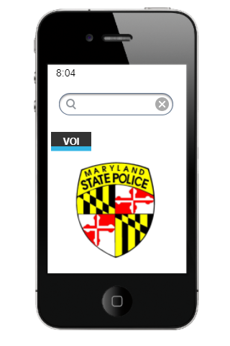

**Internal UI functionality**:

| UI Component Name | Component Value | Features | HTML Components |
| --- | --- | --- | --- |
| Time | Date/Time | Updates Periodically | <time> |
| Search | Text | Returns matches for VOI, Make or Model. | <input> |
| VOI Button | “VOI” | Returns Page with all VOI listed in a tabular arrangement, when selected. Different views for normal, hover, selected. | <script>  <form>  <button> |
| MD State Police Logo | Image | N/A | <img> |

## VOI Button Selected

**Screen Name:** VOISelected

**Image**:

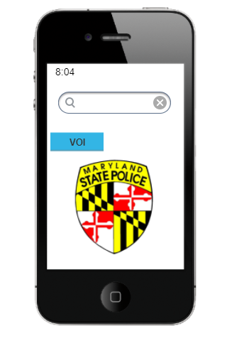

**Internal UI functionality**:

| UI Component Name | Component Value | Features | HTML Components |
| --- | --- | --- | --- |
| Time | Date/Time | Updates Periodically | <time> |
| Search | Text | Returns matches for VOI, Make or Model. | <input> |
| VOI Button | “VOI” | Returns Page with all VOI listed in a tabular arrangement, when selected. Different views for normal, hover, selected. | <script>  <form>  <button> |
| MD State Police Logo | Image | N/A | <img> |

## VOI Button Normal

**Screen Name:** VOINormal

**Image**:

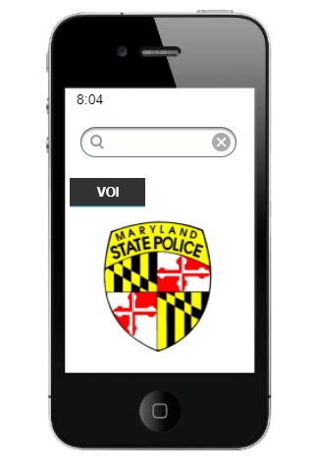

**Internal UI functionality**:

| UI Component Name | Component Value | Features | HTML Components |
| --- | --- | --- | --- |
| Time | Date/Time | Updates Periodically | <time> |
| Search | Text | Returns matches for VOI, Make or Model. | <input> |
| VOI Button | “VOI” | When selected, it returns a page with all VOI listed in a tabular arrangement. Different component views for normal, hover, selected. | <script>  <form>  <button> |
| MD State Police Logo | Image | N/A | <img> |

## VOI Table

**Screen Name:** VOIAll

**Image**:

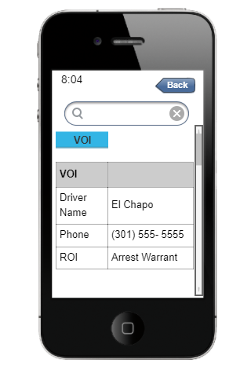

**Internal UI functionality**:

| UI Component Name | Component Value | Features | HTML Components |
| --- | --- | --- | --- |
| Time | Date/Time | Updates Periodically | <time> |
| Search | Text | Returns matches for VOI, Make or Model. | <input> |
| VOI Button | “VOI” | Returns Page with all VOI listed in a tabular arrangement, when selected. Different views for normal, hover, selected. | <script>  <form>  <button> |
| VOI Table | Tabular | N/A | <td>  <tr>  <table> |
| Back Button | Back | Returns the user to either VOIAll or VOISelected, depending on current context. | <script>  <form>  <button> |

## 2.2.1. VOI Error Reporting

**Screen Name:** VOIDataInputError

**Image**:

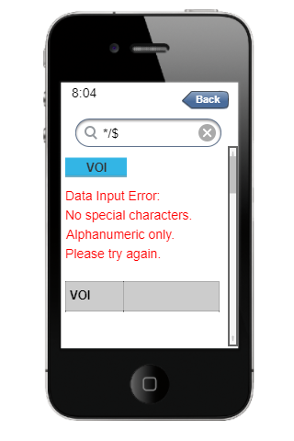

**Internal UI functionality**:

| UI Component Name | Component Value | Features | HTML Components |
| --- | --- | --- | --- |
| Time | Date/Time | Updates Periodically | <time> |
| Search | Text | Data Validation w/ Error Msg. | <p> |
| VOI Button | “VOI” | Returns Page with all VOI listed in a tabular arrangement, when selected. Different views for normal, hover, selected. | <script>  <form>  <button> |
| VOI Table | Tabular | N/A | <td>  <tr>  <table> |
| Back Button | Back | Returns the user to either VOIAll or VOISelected, depending on the current context. | <script>  <form>  <button> |

## 2.2.1. VOI Error Reporting

**Screen Name:** VOINoData

**Image**:

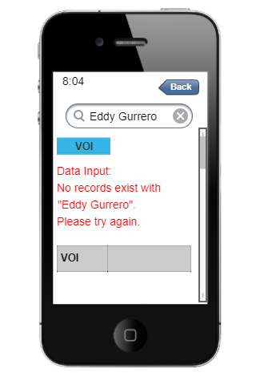

**Internal UI functionality**:

| UI Component Name | Component Value | Features | HTML Components |
| --- | --- | --- | --- |
| Time | Date/Time | Updates Periodically | <time> |
| Search | Text | Returns matches for VOI, Make or Model. | <input> |
| VOI Button | “VOI” | Returns Page with all VOI listed in a tabular arrangement, when selected. Different views for normal, hover, selected. | <script>  <form>  <button> |
| VOI Table | Tabular | N/A | <td>  <tr>  <table> |
| Back Button | Back | Returns the user to either VOIAll or VOISelected, depending on the current context. | <script>  <form>  <button> |